Artificial Intelligence and Machine Learning
Project Documentation format
1. Introduction
• Project Title: Deep Learning Fundus Image Analysis for Early Detection of Diabetic Retinopathy
•Diabetic Retinopathy (DR) is a diabetes complication that affects the eyes. Early detection is critical to prevent blindness.
Team Members:
Team ID : LTVIP2026TMIDS83275
Team Member: Meher Divakar – Model Development
Team Member: __________ – Data Collection & Preprocessing
Team Member: __________ – Frontend Developer
Team Member: __________ – Backend Developer & Testing Lead

2. Project Overview
Purpose:
This project uses Deep Learning techniques to detect and classify Diabetic Retinopathy (DR) from retinal fundus images. The goal is to assist ophthalmologists in early diagnosis, reduce manual screening time, and prevent vision loss through early intervention.

Features:
1. Intelligent Image Classification
The system uses Convolutional Neural Networks (CNN) to classify retinal images into:
- No DR
- Mild DR
- Moderate DR
- Severe DR
- Proliferative DR
It converts complex retinal patterns into accurate predictions.

2. Robust Image Preprocessing Pipeline
Includes:
- Image resizing (224x224)
- Normalization
- Noise reduction
- Pixel scaling
- Data augmentation (optional)
Ensures high-quality model input and improved accuracy.

3. Performance Optimization & Hyperparameter Tuning
Uses:
- Adam Optimizer
- Learning rate tuning
- Dropout layers
- Early stopping
- Batch size optimization
Reduces overfitting and improves generalization.

4. Comprehensive Evaluation Metrics
Model evaluated using:
- Accuracy
- Precision
- Recall
- F1-Score
- Confusion Matrix
- ROC-AUC Curve
Ensures reliable and validated model performance.

5. Scalable & Modular Architecture
Designed to integrate with:
- Web applications
- Hospital systems
- Cloud platforms
- Mobile health apps

6. Medical Decision Support
Provides:
- DR Stage
- Confidence Score
- Risk Level Indicator
Supports clinical decision-making (not replacing doctors).

7. Real-World Healthcare Applicability
System can be used in:
- Rural health camps
- Hospitals
- Telemedicine platforms
- Government screening programs

8. Extensibility with Future Technologies
Can be enhanced with:
- Real-time camera scanning
- Multi-disease detection
- Cloud deployment
- AI-based treatment recommendation

3. Architecture
Fig.1: Technical Architecture
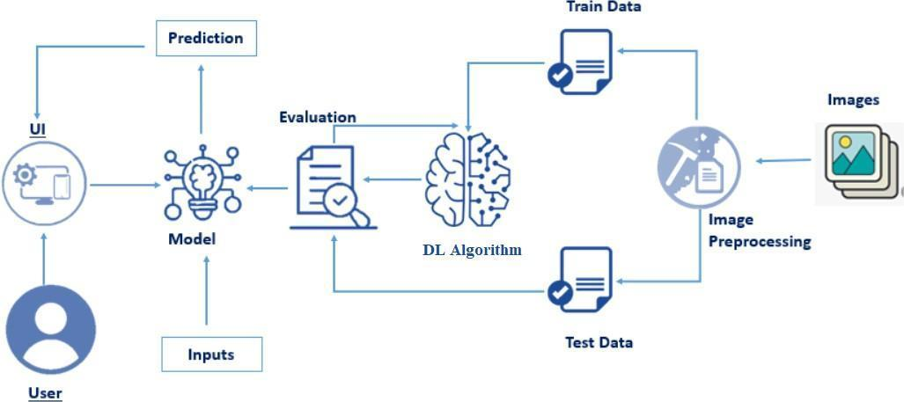

Overview of Technical Architecture
1. Data Layer
Retinal fundus images stored in dataset folder (Kaggle DR dataset).

2. Data Preprocessing Module
- Image resizing
- Normalization
- Data augmentation
- Train/Test split

3. Training and Testing Split
- Training Data (80%)
- Testing Data (20%)
Prevents overfitting and ensures proper evaluation.

4. Deep Learning Algorithm Layer
CNN Model:
- Convolution Layers
- Pooling Layers
- Dropout
- Fully Connected Layer
- Softmax Output
Model learns retinal lesion patterns.

5. Model Evaluation Module
Evaluates:
- Accuracy
- Confusion Matrix
- Classification Report
- Validation Loss

6. User Interface (UI) Layer
Web-based interface allows users to:
- Upload fundus image
- View prediction
- See probability score

7. Prediction Module
User uploads image → Model processes → DR stage predicted → Result displayed.

Architecture Flow:
Image Dataset → Preprocessing → Train/Test Split → CNN Model → Evaluation → Flask UI → Prediction

4. Setup Instructions
Prerequisites:
- VS Code
- Python 3.x

Installation:
Open terminal and install:
pip install numpy
pip install pandas
pip install tensorflow
pip install keras
pip install matplotlib
pip install seaborn
pip install scikit-learn
pip install opencv-python
pip install flask
pip install joblib

5. Folder Structure
Client (Frontend)
Templates Folder:
- index.html – Landing page
- predict.html – Image upload form
- results.html – Prediction results page
- adaptivity.html – Additional information page
Frontend collects image input and displays results.

Server (Backend)
- app.py – Flask application
- model.h5 – Trained CNN model
- requirements.txt
- static/
- templates/

Server Flow:
User Upload → Flask Backend → Image Preprocessing → CNN Model → Prediction → Result Display

6. Running the Application
1. Dataset Collection
Dataset downloaded from Kaggle DR dataset.

2. Exploratory Data Analysis (EDA)
Univariate Analysis
- Class distribution analysis
- DR severity frequency plot
Multivariate Analysis
- Severity vs Age
- Severity vs Image Features

3. Data Preprocessing
- Remove corrupted images
- Normalize pixel values
- Encode labels
- Split dataset

4. Model Building
CNN Model trained with:
- Adam Optimizer
- Categorical Crossentropy
- Epochs: 25
- Batch Size: 32
Evaluated using:
- Confusion Matrix
- Classification Report
- ROC Curve

5. Server-Side Application
Flask /predict route:
- Accept image upload
- Preprocess image
- Predict DR stage
- Return prediction + probability

7. API Documentation
Endpoint | Method | Description
/ | GET | Loads main page
/predict | GET | Loads prediction form
/predict | POST | Returns prediction via form
/api/predict | POST | Returns prediction in JSON
/adaptivity | GET | Loads information page

API JSON Example
Request:
{
"image": "base64_encoded_image"
}
Response:
{
"prediction": "Moderate DR",
"confidence": 92.4
}

8. User Interface
Fig.2 – Home Page
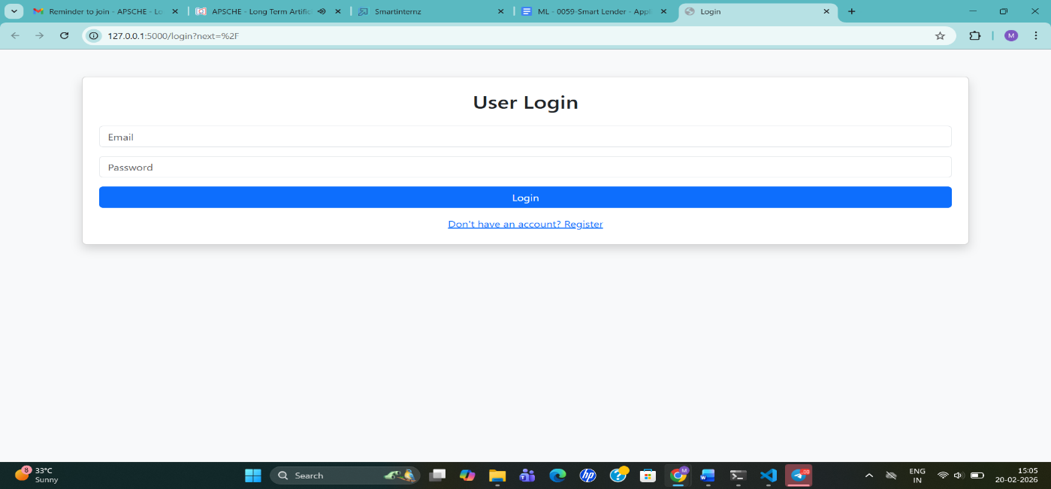
Fig.3 – Image Upload Page
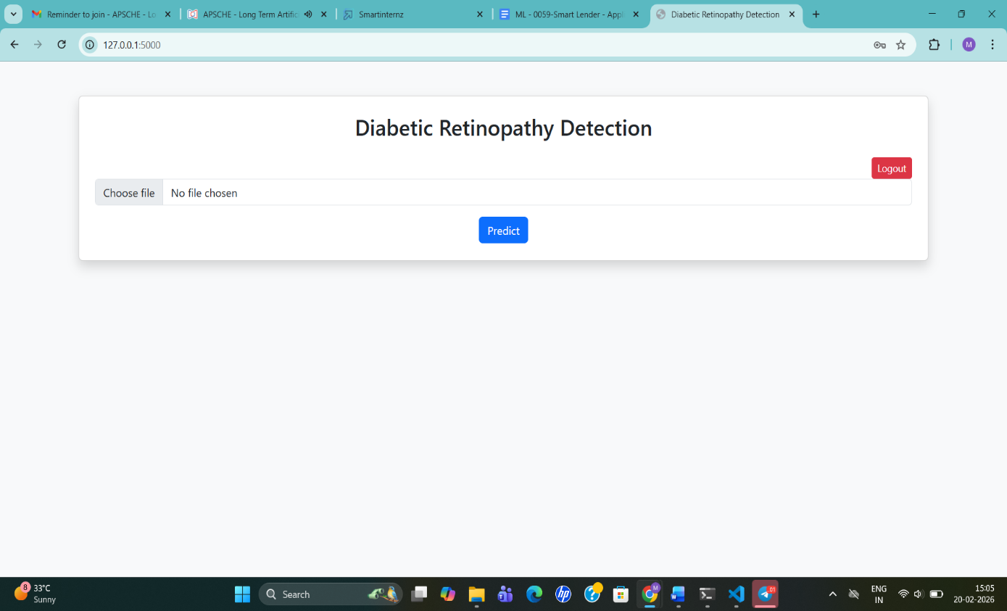

9. Testing
Testing Strategy
Functional Testing
- Verified routes
- Image upload
- Prediction output
API Testing
- JSON image input
- Error handling
Model Validation
- Checked class balance
- Verified prediction consistency

Tools Used
- Manual Browser Testing
- Postman
- Flask Debug Mode
- NumPy & TensorFlow

10. Screenshots / Demo
Fig.4 – Results Page

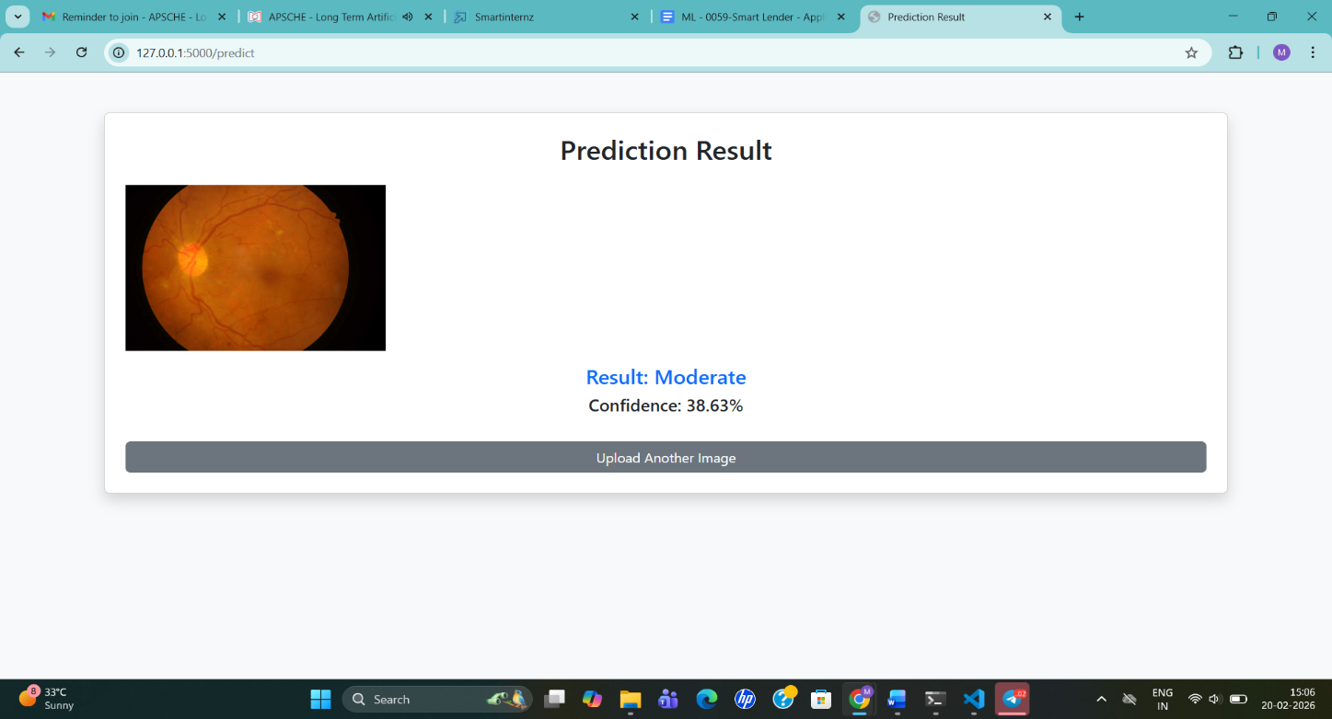

11. Known Issues
- Limited dataset diversity
- Slight overfitting risk
- Large image upload slows response
- Model interpretability limited (black-box issue)

12. Future Enhancements
- Add Grad-CAM visualization
- Deploy on cloud
- Add PDF medical report download
- Integrate doctor dashboard
- Multi-disease detection

